The purpose of this document is to provide information of all board level modifications over existing BOM and Schematics for the “200W DC/DC LLC Resonant Converter Reference Design-EP”, to make it compatible with latest Voltage Mode Control and Average Current Mode Control (VMC and ACMC) Firmware. All the below board level modifications are already carried out in the reference design units with -EP suffix.
1) Output inductor L4 is shorted by adding a thick copper wire which can carry ~17A continuous current across the component pads on the PCB. Figure 1 below shows a circuit equivalent while Figure 2 below shows the terminals to short on the PCB.

Figure 1: Updated Circuit with output inductor shorted

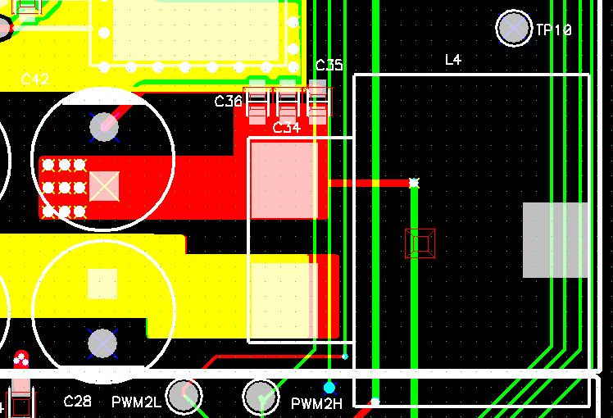
Figure 2: Location of Inductor L4 and Short Point

2) Current feedback components R13, R11, and C11 are modified as shown in Table 1. Figure 3 below shows the three component locations in the circuit and Figure 4 below shows the corresponding PCB locations.

Figure 3: Updated circuit components highlighted

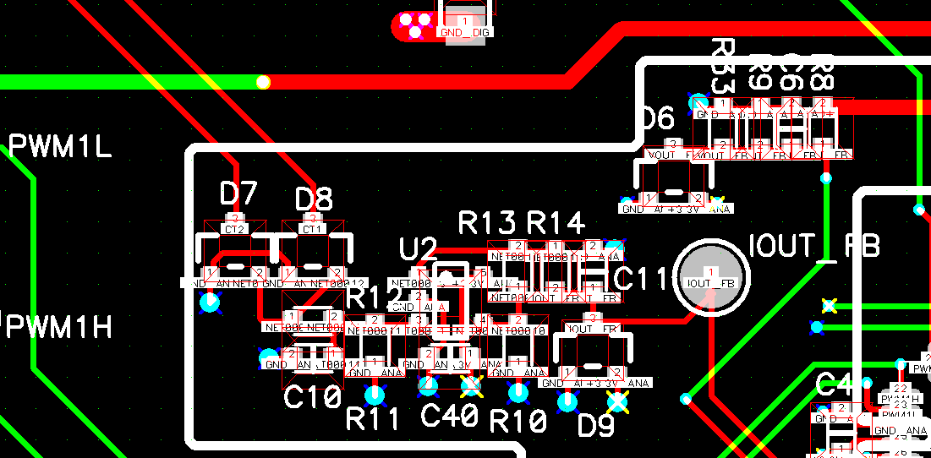
Figure 4: Location of current feedback components

3) The “200W DC/DC LLC Resonant Converter Reference Design-EP”, is controlled by dsPIC33EP16GS502 (U1) as shown in Figure.5

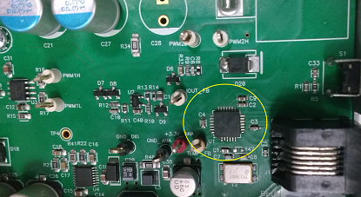
Figure 5: Location of dsPIC controller IC U1 on PCB
The table below shows the new components chosen for C11, R13, R11 and U1.
Table1: List of Component Modifications

